Temperature cycling series
-------------------------------------------------- -----------------
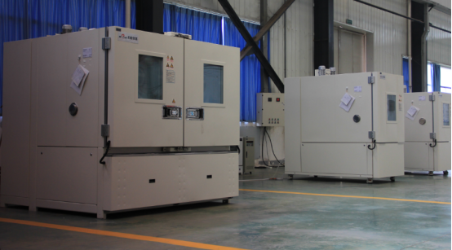
Temperature cycling series equipments are used in Screening tests and failure mode assessment of optoelectronic devices, interconnect circuits, components and electronic equipment. It is an effective method to found product design defects and process problems .Temperature change rate is generally less than 20 ℃ / min, the product can be used to investigate product failures caused by thermo-mechanical properties to truly reproduce the application environments of the measured sample.When large parts of the material constituting the product of each thermal matching is poor, or internal component stress, the temperature cycle test can cause product failure resulting from mechanical deterioration of structural defects.

The following are subdirectories for this series of products:
-------------------------------------------------- -------------------------------------------------- ------------------
Programmable temperature test chamber (WGD series)
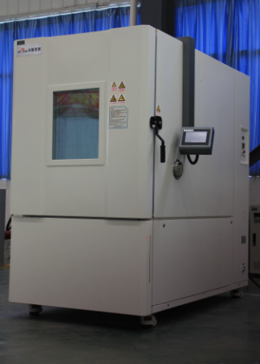
Execution and meet the standard:

Uses: Widely used in cold test and cryogenic storage of electrical products, materials, components and equipment in aerospace, aviation, information, electronics, instrumentation and other industries.

Features:
· Dual-stage compressor, super-cooling capacity
Highest temperature change ability like surface temperature change rate 20 ℃ / min, up to a predetermined maximum rate of temperature change test capability.
· Temperature evenly distributed, perfectly linear control
The use of air volume & wind speed automatic adjustment, high-speed processing temperature controllers and electronic expansion valves and other advanced technologies, curb the temperature difference of the sample, to achieve a linear control accuracy.
· Sample surface temperature and air temperature modes
Use the sample surface temperature sensor enables temperature control sample test conditions to meet the test requirements JESD-A104-D-like surface temperature change rate of 15 ℃ / min. Effective internal volume 200ℓ, covers an area of only 2 ㎡.

Technical parameters:

Model
Temperature Range
Internal volume
Internal dimensions (W × H × Dmm)
WGD702
-70 ~ + 180 ℃
200L
800 × 500 × 500

Rapid temperature change test chamber
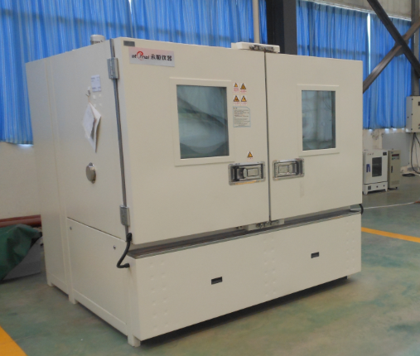
Execution and meet the standards: IEC60068-3-5, IEC60068-3-6
Purpose: To achieve rapid temperature change, find product design defects and process issues

Features:
· Complete, rich product line
There are 580L and 800L, two product ranges to choose from.Rapid temperature range 5 ℃ / min, 10 ℃ / min, 15 ℃ / min and 20 ℃ / grading available for selection.Deliver same performance in the smallest footprint of similar models.Meet the internationally accepted test standards.
· Nice appearance, refined smart controller
Stainless steel liner and outside bile, easy maintenance and long life.Zhuo Xi originally developed controller, easy to use, easy to disassemble and easy to transport.

Rich and practical accessories and optional parts
Aluminium condensate switch, scroll compressor, solid state electrostatic sensor, low humidity range ensures reliability features like low noise and others.

Technical parameters:

Model
Temperature Range
Humidity range
Internal volume
Temperature change rate
Other parameters
ZXDK1058AL
-40 ~ + 180 ℃
10 ~ 95% RH
580L
Type 3
10 ℃ / min
ZXDK1558AL
-40 ~ + 180 ℃
10 ~ 95% RH
580L
Type 3
15 ℃ / min
ZXDK0580AL
-40 ~ + 180 ℃
10 ~ 95% RH
800L
Type 4
5 ℃ / min
ZXDK1080AL
-40 ~ + 180 ℃
10 ~ 95% RH
800L
Type 4
10 ℃ / min
ZZXDK1080AL
-40 ~ + 180 ℃
10 ~ 95% RH
800L
Type 4
15 ℃ / min
ZXDK2080AL
-40 ~ + 180 ℃
10 ~ 95% RH
800L
Type 4
20 ℃ / min

HIDDEN TEXT
This section contains tooltips, titles and other text that are usually hidden in the body of the HTML page. This text should be translated to bring the entire page into your language.
HTML ELEMENTS
Temperature cycling series

