High-temperature series

This series is widely used in the aerospace, automotive, electronics, materials, energy, chemical, medical, pharmaceutical and other industries for high temperature test and heat treatment process.It can do aging, drying, baking, curing, bonding, degassing treatment to a variety of products, parts and materials to meet the suitability test requirements of being stored, being transported, service life and so on, in a high temperature and constant temperature environment.
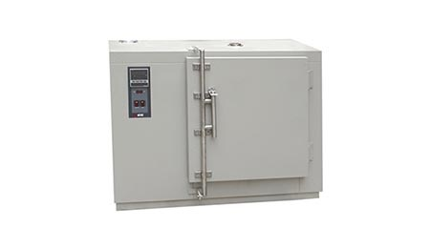

Explosion-proof high temperature test chamber

Execution and meet the standard:
Uses:
Suitable for testing and heat treatment of batteries, resin, paint and other inflammable and explosive materials

Features:
· Equipped with special explosion-proof pressure relief device
· Safe and reliable door lock to prevent the automatic opening
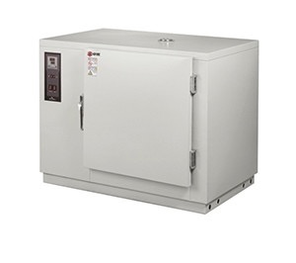
Technical parameters:

Temperature range: RT + 20 ~ + 200 ℃;
Internal dimensions: 225L ~ 2,640L

High temperature test chamber

Execution and meet the standards: GB/T2423.2 / IEC60068-2-2
Uses: Suitable for heat treatment and drying treatment of production line
Features:
· Complete series, classic style, using both setpoint control method and program control method.
Setpoint control mode can be set to automatically start and end, program control mode can implement program settings containing 10 patterns, each pattern can have 20 steps.Meet with the need of the temperature characteristic tests which include slope setting of temperature rise and drop.
. High reliability for harsh environment
·High-quality and high-reliability materials are applied for hanldes, hinges, touch screen controller, Sealing strip etc. to make it durale.
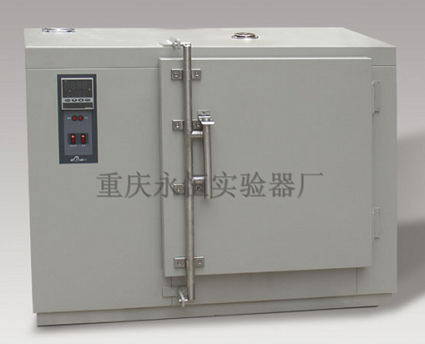

Technical parameters:

Model | WG
 | 201B | 202B | 203B | 205B | 401B | 402B | 403B | 405B
Temperature Range | R.T + 10 ~ 200 ℃ |  |  |  | R.T + 10 ~ 400 ℃
Temperature fluctuation | ± 0.5 ℃
Temperature deviation | ≤2 ℃ |  |  |  | ≤2 ℃ (when below 200 ℃) ≤7 ℃ (when at 400 ℃)
Thermal insulation  materials | Ultra-fine glass fiber |  |  |  | Aluminium silicate
Door seal | Silicon rubber bar |  |  |  | High temperature double layer dust-free asbestos strip
Internal space dimension | Type 1  450 × 450 × 450 |  | Type 2  550 × 550 × 550 |  | Type 3  650 × 650 × 700 |  | Type 4  700 × 800 × 900
Internal volume | 91L |  | 160L |  | 270L |  | 500L
Power supply | 220V 50Hz |  |  |  | 380V 50Hz
Remark | Inside and outside dimensions labeled: Depth D × Width w × Height H

Anaerobic high temperature test chamber

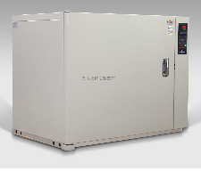
Execution and meet the standard:
Purpose: Implement experimental hypoxic environment by inert gas
Features: Adjustable when oxygen concentration is 0.5% or above
All-around seamless Ar - arc - welding liner
Automated easy operation, one key to start, avoid the manual errors

Technical parameters:
Temperature range: RT + 20 ~ + 300 ℃;
Inner dimensions: 226L; oxygen concentration: 0.5 to 21%

Drying chamber

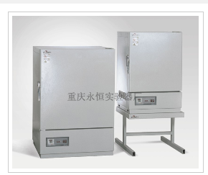

Execution and meet the standards: JB / T5520-1991 drying chamber technical conditions

Uses: This chamber is designed for drying, baking and heat treatment tests for non-flammable, non-explosive materials performed by Electronics, electrical, instrument, material, semiconductor manufacturing enterprises; it is particularly suitable for products such as LED, LCD, quartz crystal, capacitors, resistors and other products which demands constant temperature precision and high reliability drying and aging during the process of production

Features:
• Strong wind circulation
• Man-machine dialogue, easy to set up, simultaneous display the set temperature and the measured temperature;
• Over-temperature protection, improved reliability and safety;
• Convenient linear compensation function, avoid the deviation between display temperature and actual temperature values;
• Unique assembly design, more reasonable case structure;

Technical parameters:

Model
CS101
1EBN
2EBN
3EBN
Temperature Range
R.T + 10 ~ 300 ℃
Temperature fluctuation
± 0.5 ℃
Maximum temperature arrival time
70min
Temperature deviation
± 2.5% ℃
Insulation materials
Ultra-fine glass fiber
Door seal
Eco-friendly silicone rubber
Internal space dimension
400 × 450 × 400
500 × 550 × 500
600 × 650 × 600
Internal volume
72L
138 L
234 L
Remark
Inside and outside dimensions labeled: Depth D × Width w × Height H

Clean high temperature test chamber
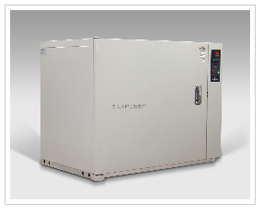
Execution and meet the standards: ISO16750, JESD22, GB / T2423.1 (IEC60068-2-1), GB / T2423.2 (IEC60068-2-2), GB / T 14710, GB / T 13543

Uses: Clean-room dedicated high-temperature equipment.

Features:
* Cleanliness class 100 clean heat treatment
HEPA filter with front wind horizontal parallel flow cycle to successfully ensure the uniformity of the temperature distribution within the box and class 100 cleanliness. Minimal control of wind speed and distance.
Programmable control
Each pattern contains 20 steps, up to 10 patterns available.The temperature rising and falling edge setting program repetitions at 1-999 times between settings.
Easy-to-operate standard meter installed.
Standard configuration setting operation mode and automatically starts · automatic stop operation can be set to run.
Standard configuration of overheat prevention device

Technical parameters:
Model
DGP
2568BN
2576BN
2587BN
25110BN
Temperature Range
R.T + 20 ~ 250 ℃
Temperature fluctuation
≤ ± 0.5 ℃
Temperature rising time
Ambient temperature ~ + 150 ℃ in about 10 minutes (non-linear load) Ambient temperature ~ + 250 ℃ in about 30 minutes
Internal space dimension
600 × 950 × 1200
650 × 900 × 1300
650 × 900 × 1500
800 × 950 × 1500
Internal volume
680L
760 L
880 L
1140 L
Remark
Inside and outside dimensions labeled: Depth D × Width w × Height H

ZK series vacuum drying oven
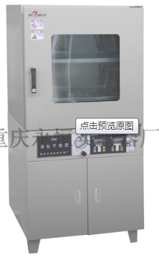

Execution and meet the standard:
Uses: This product provides the appropriate temperature and low pressure environment for vacuum state thermal experiments in electrical, electronics, aviation and other related fields, and other purposes.
Features:
· Rectangular working chamber provides maximum effective volume;
· Bulletproof high temperature glass observation window
* Optional recorder and printer;
Technical parameters:
Temperature range R.T + 10 ~ 200 ℃
Vacuum degree <133Pa
Internal volume: 90-300L

Temperature sintering chamber

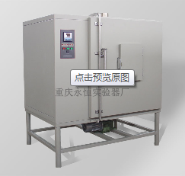

Execution and meet the standard:
Uses: This type of container can be used by factories and/or research units for sintering compression molding products like plasticity tetrafluoroethylene, ethylene, etc,
and high-temperature thermal aging test for plasticity molecular materials (rubber, plastic, etc.), electrical insulation materials and various of low-melting point materials,
it is ideal to production units for baking high-temperature new plastic, dry heat treatment and other heating thermostats.

Features:

Technical parameters:
Inner dimetions : 1000 × 1000 × 1000mm (Depth D × Width W × Height H)
Internal volume: 1000L
Turntable size : ¢ 800mm
Temperature range: RT + 10-450 ℃

·

